VIRTUAL ART GALLERY

Artists Table

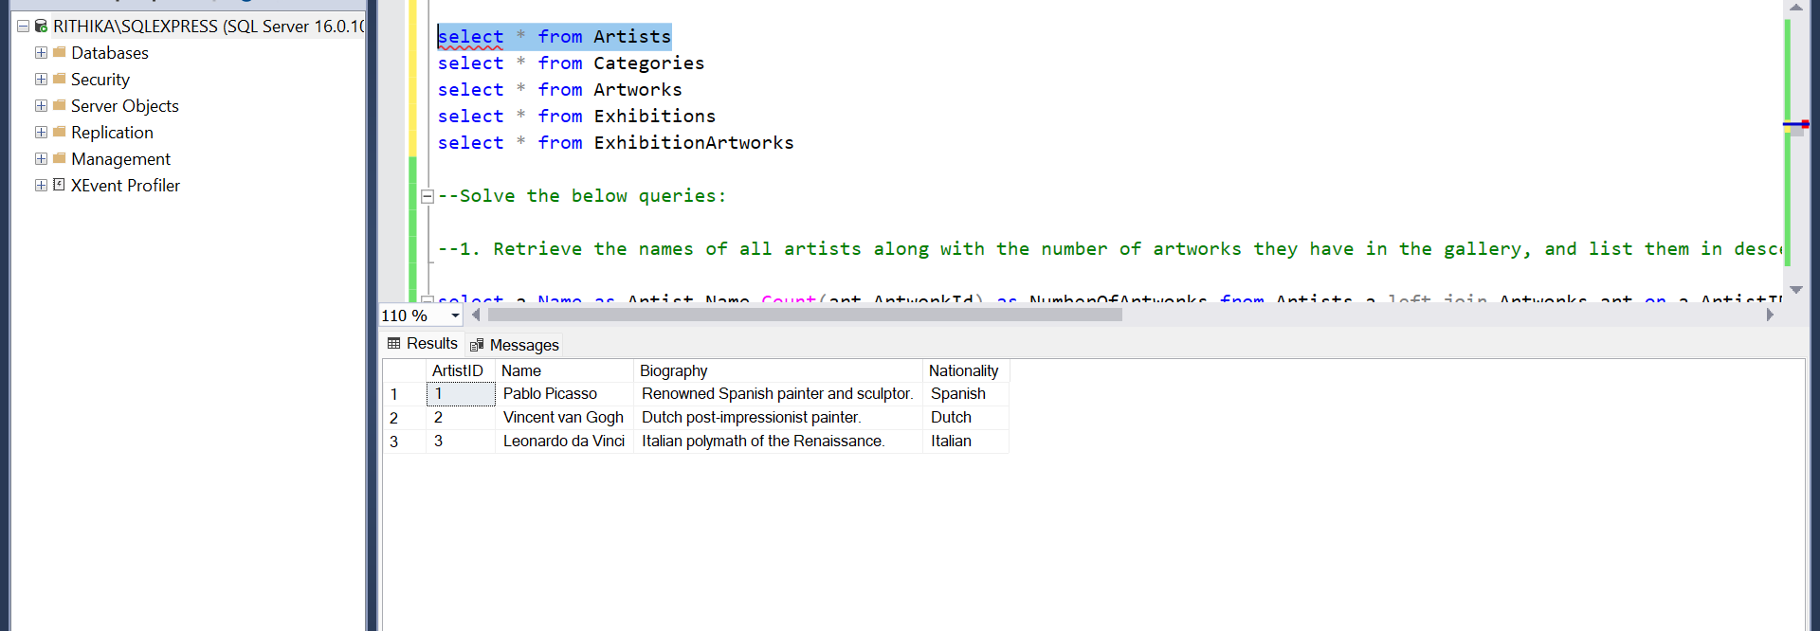

Category Table

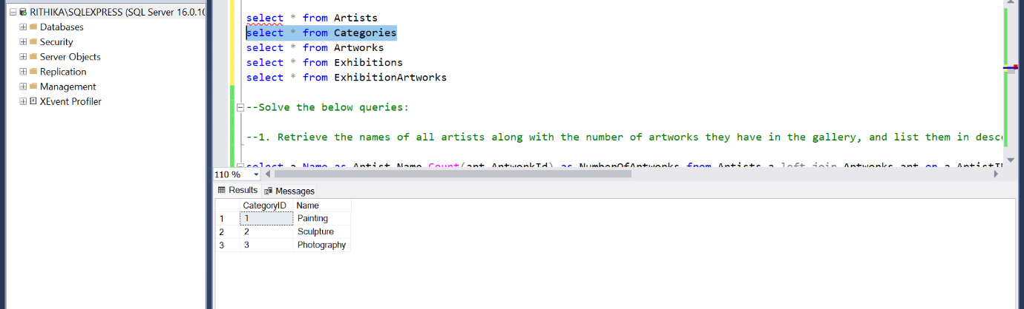

Artwork Table

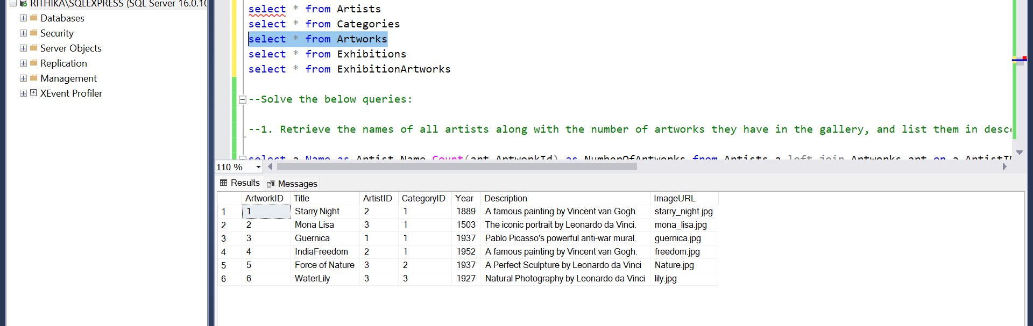

Exhibitions Table

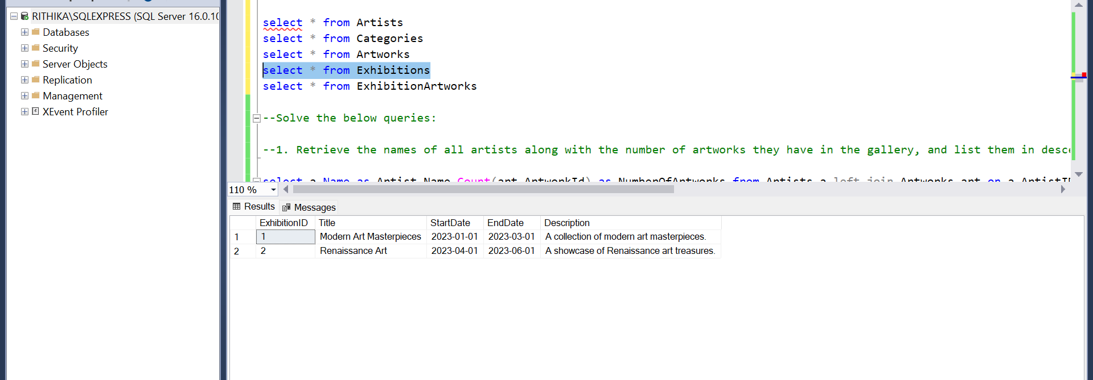

Exhibition Artworks Table

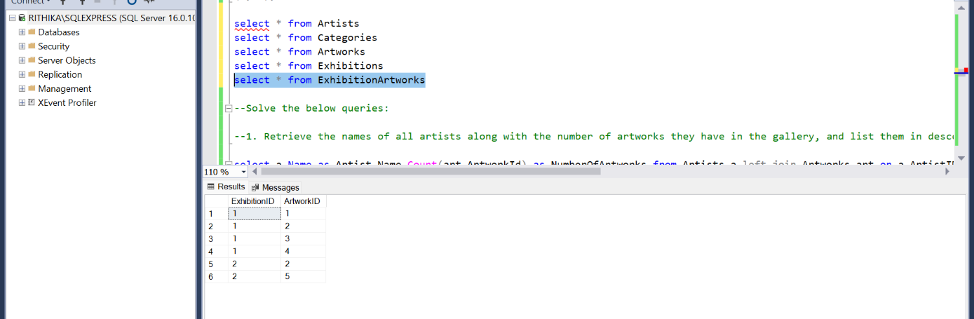

**--Solve the below queries:**

**--1. Retrieve the names of all artists along with the number of artworks they have in the gallery, and list them in descending order of the number of artworks.**

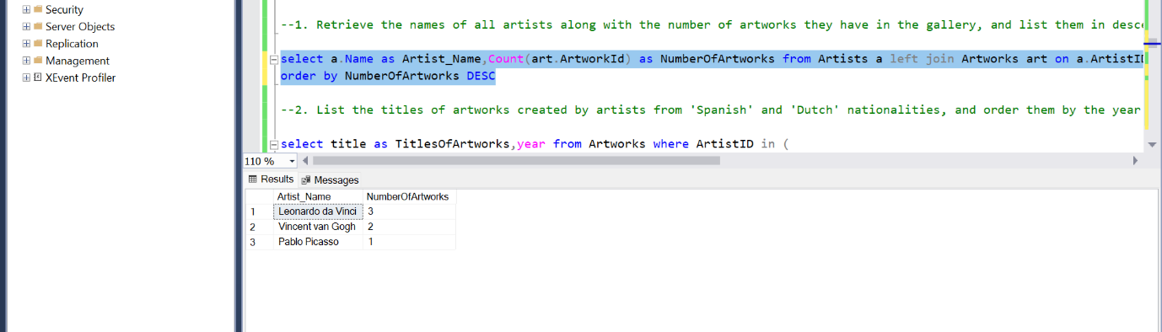

**--2. List the titles of artworks created by artists from 'Spanish' and 'Dutch' nationalities, and order them by the year in ascending order.**

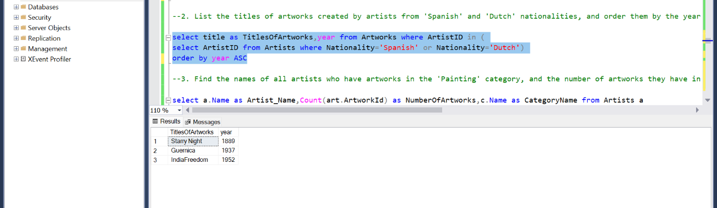

**--3. Find the names of all artists who have artworks in the 'Painting' category, and the number of artworks they have in this category.**

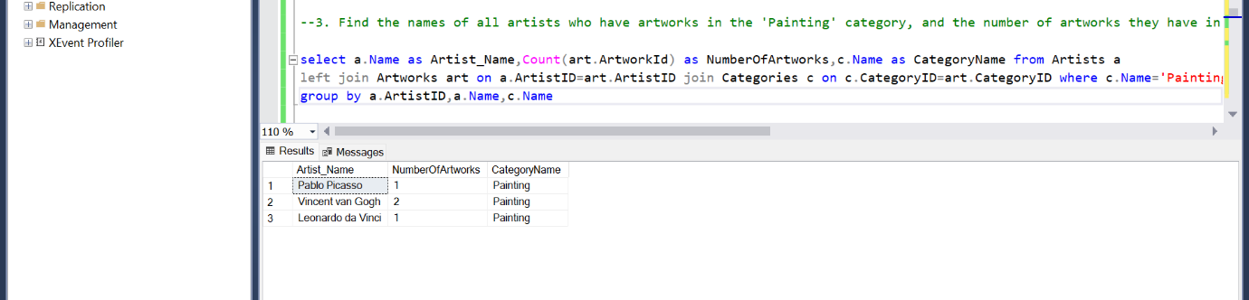

**--4. List the names of artworks from the 'Modern Art Masterpieces' exhibition, along with their artists and categories.**

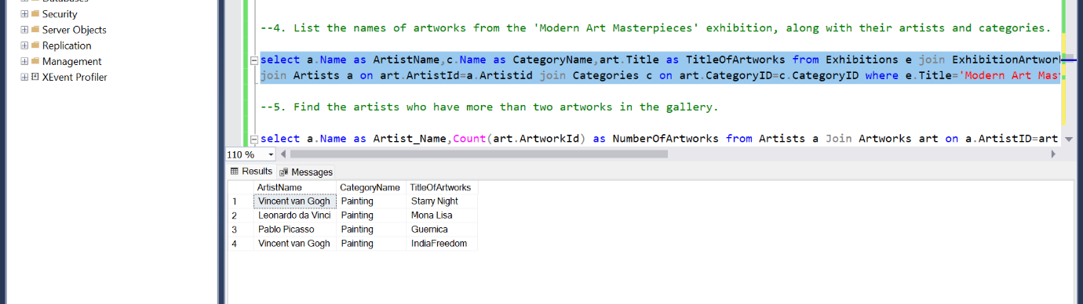

**--5. Find the artists who have more than two artworks in the gallery.**

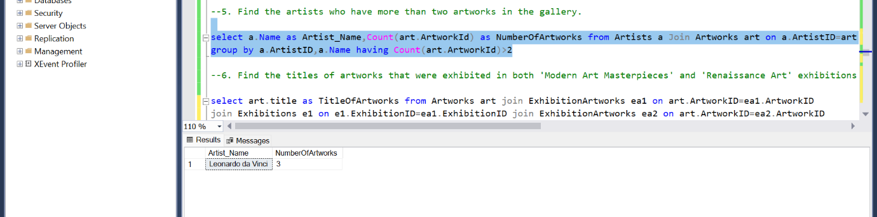

**--6. Find the titles of artworks that were exhibited in both 'Modern Art Masterpieces' and 'Renaissance Art' exhibitions**

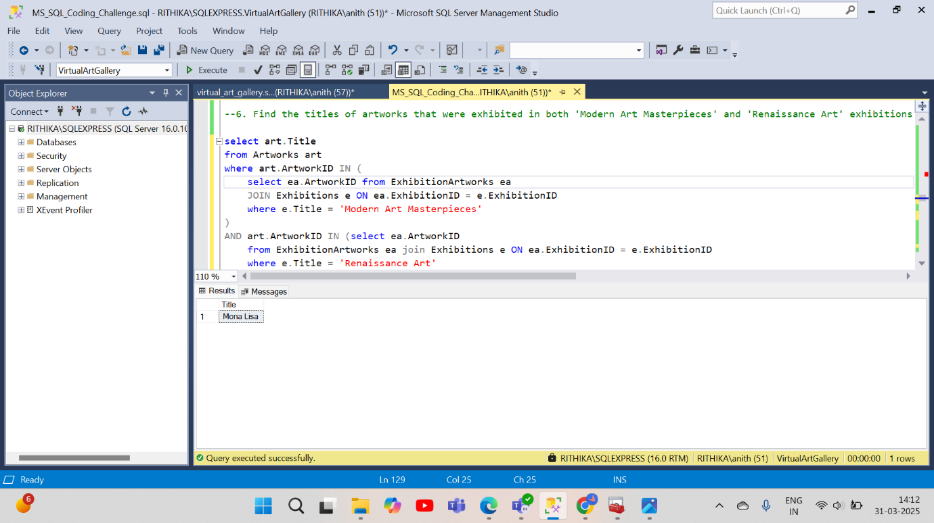

**--7. Find the total number of artworks in each category**

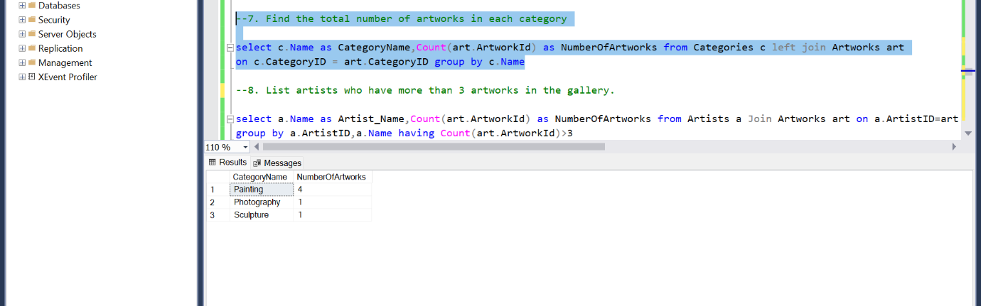

**--8. List artists who have more than 3 artworks in the gallery.**

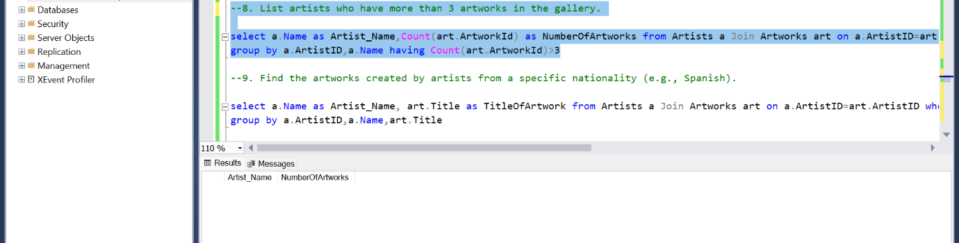

**--9. Find the artworks created by artists from a specific nationality (e.g., Spanish).**

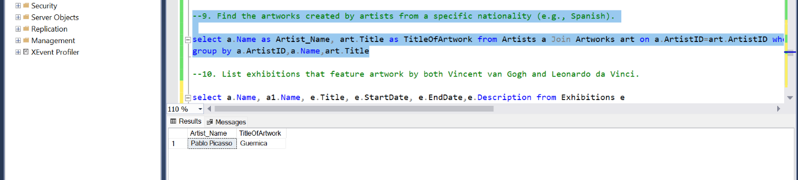

**--10. List exhibitions that feature artwork by both Vincent van Gogh and Leonardo da Vinci.**

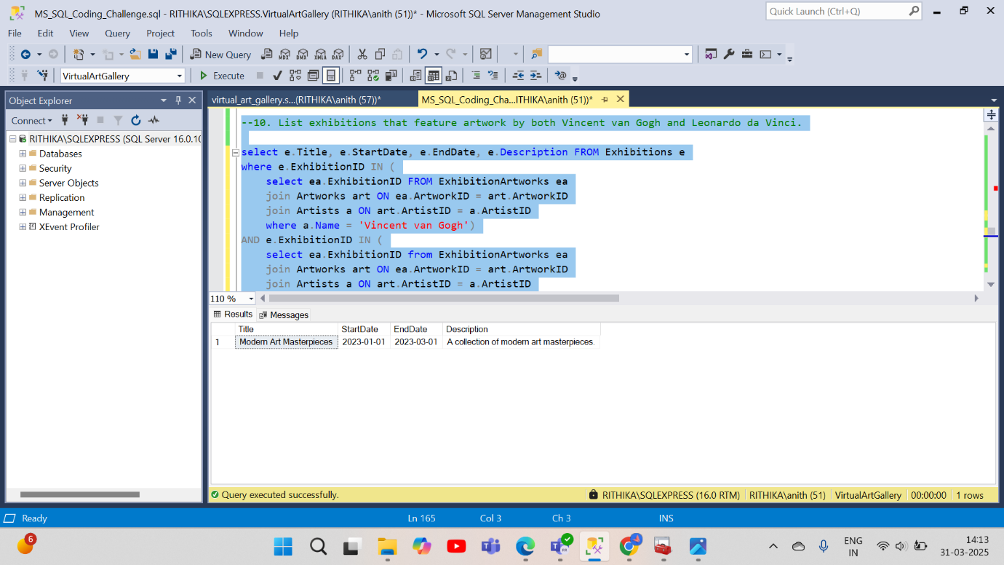

**--11. Find all the artworks that have not been included in any exhibition.**

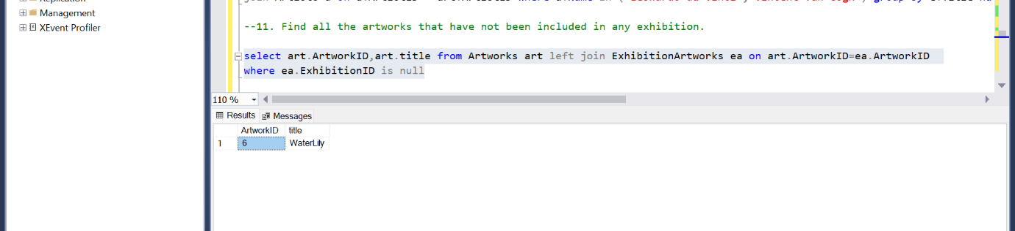

**--12. List artists who have created artworks in all available categories.**

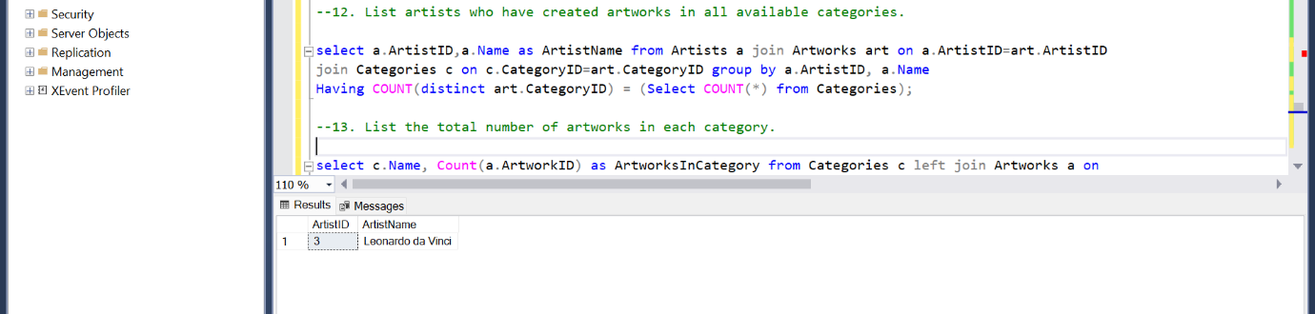

**--13. List the total number of artworks in each category.**

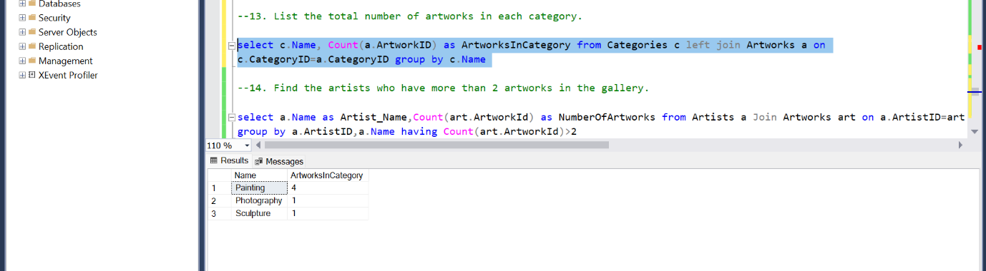

**--14. Find the artists who have more than 2 artworks in the gallery.**

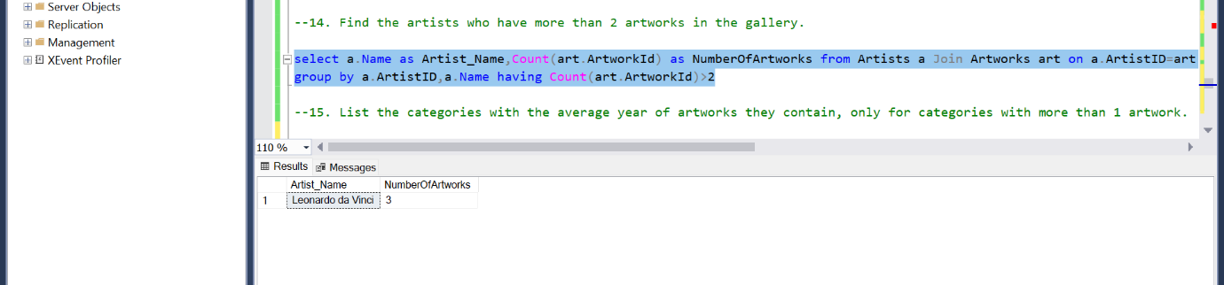

**--15. List the categories with the average year of artworks they contain, only for categories with more than 1 artwork.**

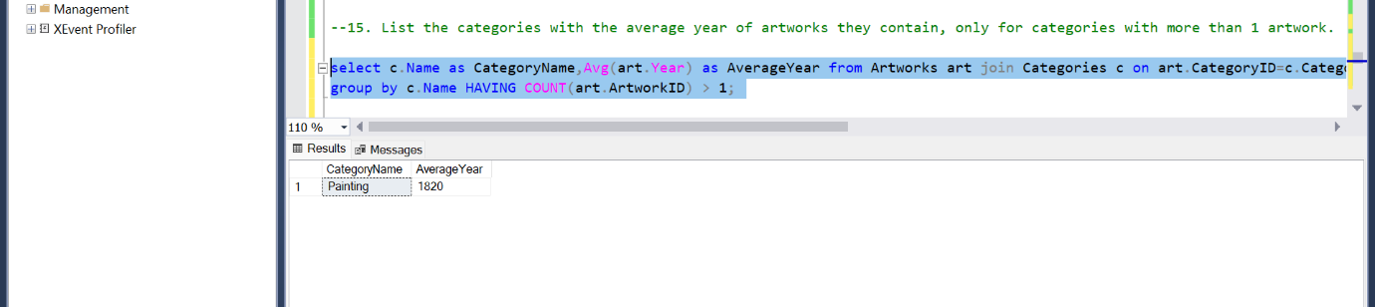

**--16. Find the artworks that were exhibited in the 'Modern Art Masterpieces' exhibition.**

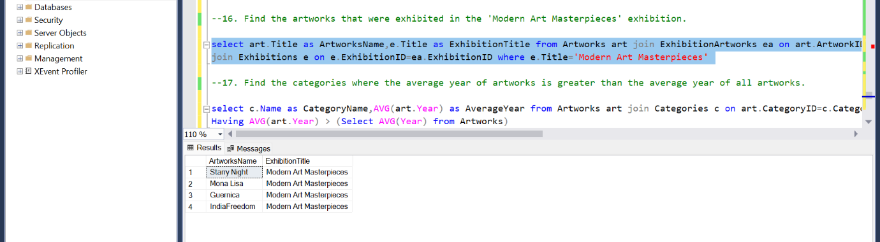

**--17. Find the categories where the average year of artworks is greater than the average year of all artworks.**

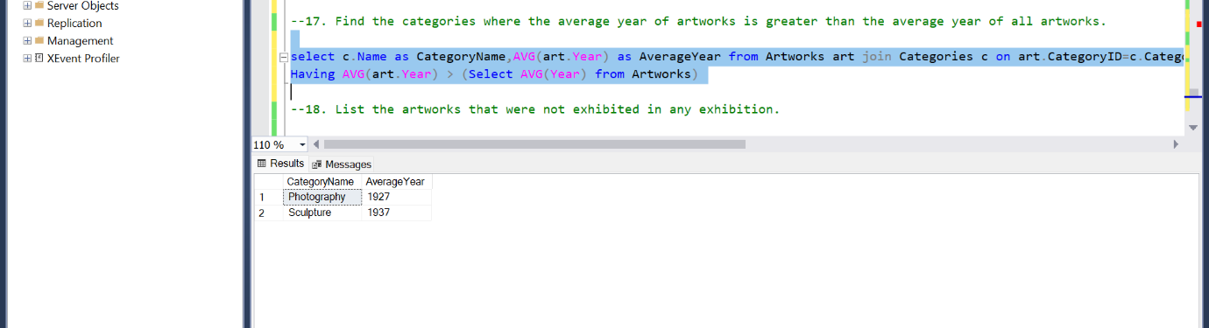

**--18. List the artworks that were not exhibited in any exhibition.**

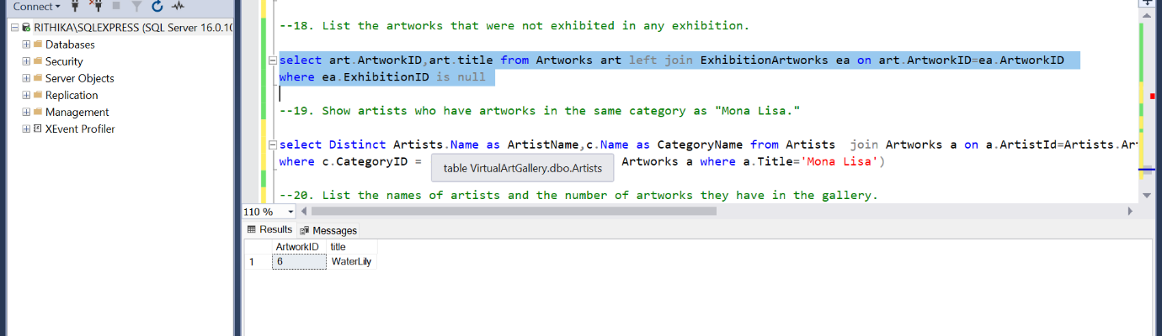

**--19. Show artists who have artworks in the same category as "Mona Lisa."**

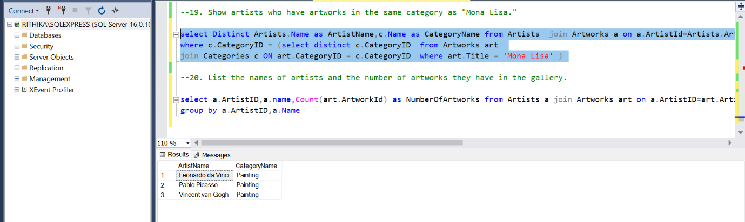

**--20. List the names of artists and the number of artworks they have in the gallery.**

